Appendix A: QDa Reservation calendar
The items and figures following provide ‘how-to’ in order to make reservations to use the QDa instrument.
- Requirements
  - You must be a member of the UNM email group: Mass Spec User UNM (massspecuserunm ‘at’ unmm.onmicrosoft.com)
  - You MUST use web version of Outlook calendar for your UNM account. The Outlook windows app does not synchronize nor allow users to make events.
- Procedure to make an instrument reservation
  - Login to loboweb (my.unm.edu/home) or directly to lobomail
  - Select the calendar icon at left
  - Under your username, expand the dropdown arrow to show “groups”
  - Select the Mass Spec User UNM calendar to enable view
  - TAKE CARE to look at existing reservations!
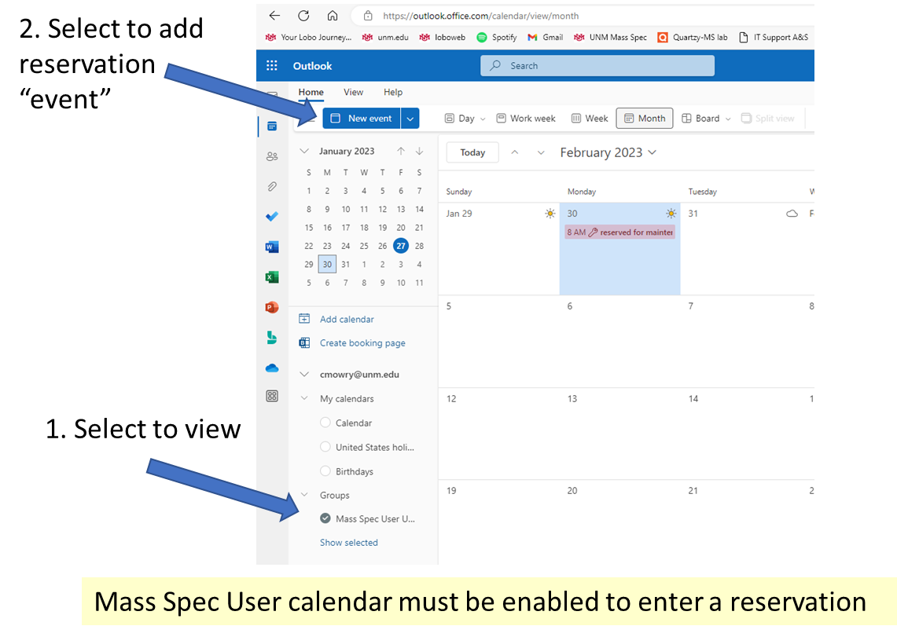
  - Click on “new event” Enter your reservation information. Make sure to select the Mass Spec User UNM calendar and to hit save.
